**EWTN Radio has created 1000+ files for you to easily capture and use on you website or social media page.**

**To access these EWTN Programming and Mother Angelica clips, go to the FTP site at** [**https://audio.ewtn.com/**](https://audio.ewtn.com/)

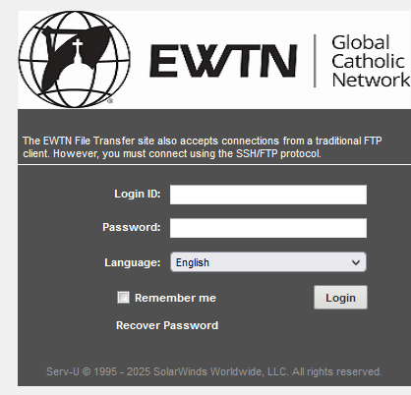

**Login ID: affiliate**

**Password: angelica1**

**Click on “-Affiliate Resources”**

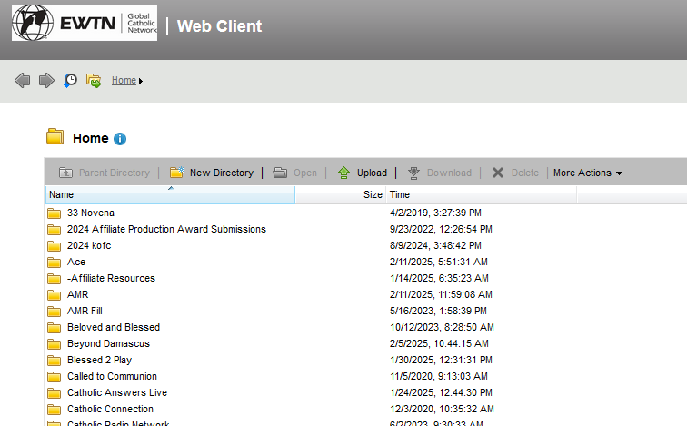

**Select “Social Media Posts”**

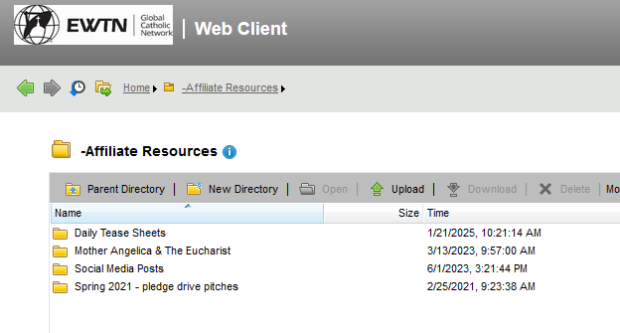

**Select the Category of Posts You’d Like. EWTN Programming will list programs by show title. All files have a very brief description as to the content of the clip.**

